***THSWPA REGION I***

***2025 REGIONAL CHAMPIONSHIPS***

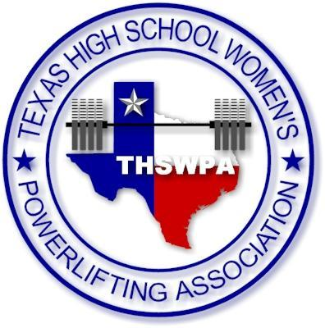**Big Spring Junior High School**

**624 E 6th Place**

**Big Spring, TX**

***ENTRY FEE $50 PER LIFTER***

***CHECKS PAYABLE TO***

***BSHS Powerlifting***

***r1 regional meet itinerary***

***Unequipped Early Weigh-in***

***2/26/2025***

***Big Spring ATC***

***707 E 11th Place***

***3:00-5:00PM***

|  |  |  |
| --- | --- | --- |
| ***Thursday, February 27th*** | ***Friday February 28th*** | ***Saturday March 1st*** |
| **Unequipped weigh ins- 1:00PM-2:00 PM**  **Judges Meeting 2:30 PM/Coaches Meeting 2:45 PM**  **Unequipped- Bars Loaded 3:00 PM**  **Early Weigh-In**  **Division 1 3:00-5:00**  **(6A/5A)** | **Division 1 weigh ins- 6:00-7:30 AM**  **Judges Meeting 7:30 AM/Coaches Meeting 7:45 AM**  **Division 1- Bars Loaded 8:30 AM**  **Early Weigh-In**  **Division 2 3:00-5:00PM**  **(4A D1/D2)** | **Division 2 weigh ins- 6:00-7:30 AM**  **Judges Meeting 7:30 AM/Coaches Meeting 7:45 AM**  **4A d2- Bars Loaded 8:30 AM**  **Flight 1-4A D2**  **Flight 2-4A D1** |

**Prices for Spectators: $8 for Adults/ $5 for Student/Children**

**There will be a full concession Stand All three Days**

**Meal Deal info: Will be Sent out ASAP**

**Regional Shirts: Fine Designs will be on site all three days for Regional Shirts.**

**ALL WEIGHS-INS (except for Unequipped) will take place at Big Spring Junior High**

**UNEQUIPPED: SINGLET HAS TO BE WORN TO COMPETE/ ALL ALLOWED ITEMS DURING THE COMPETITION ARE IN THE UNEQUIPPED RULEBOOK ONLINE @ THSWPA.COM**