THSWPA
2023 REGION V CHAMPIONSHIPS

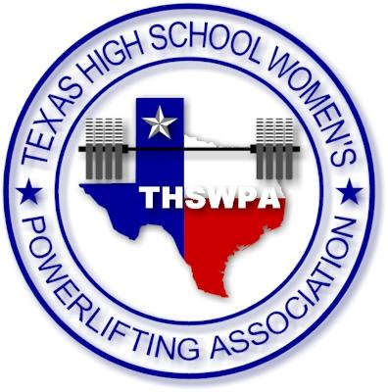
Richard M. Borchard Regional Fairgrounds
1213 Terry Shamsie Blvd
Robstown, TX 78380
ENTRY FEE $45 PER LIFTER
CHECKS PAYABLE TO
San Diego Powerlifting Activity Account
packets will include:
1 wrist band (coach) more than number of lifters up to 4 wristband max
Regional qualifying lifters will receive wristband upon being weighed in
you may purchase up to 2 wrapper wristbands per team @ $10.00 each at registration
regional meet itinerary

Friday march 3rd
Early Weigh Ins
3:00pm – 5:00pm
Saturday march 4th
Weigh Ins
5:30am – 7:00am
judges meet at 7:10
Coaches meet at 7:25
National Anthem 7:55
Competition starts at 8:00
Bench at 10:00
Lunch at 11:30
Deadlift at 12:30
Awards Ceremony at 3:00
Important Information
No ice chests or food will be allowed; Clear bag policy is in effect
Dues must be paid in order to compete
Declarations must be made by Monday February 20 & no later than 4pm; at this time, each school will become responsible for the entry fee for each lifter they have qualified
Alternates are encouraged to attend, but will need a separate check; no refunds/change
Required Forms: Eligibility, Drug affidavit, Regional/State Release
6 Platforms; Three Flights (assignments TBD)
Admission: $10 at the Gate; No online ticket sales
parking is $5
For questions, comments, or concerns please contact me via text or email.
(956) 472-1825 / tmartinez@sdisd.us

Tomas Martinez
Director - Region V Div. 3
THSWPA – Vice President

