T H S W P A
Texas High School Women's Powerlifting Association

Coaches
THE REGION v DIVISION I REGIONAL MEET WILL BE HELD AT THE BERT OGDEN ARENA IN EDINBURG, SPECTATORS WILL BE ALLOWED, THEY MAY PURCHASE TICKETS EITHER ON-LINE OR AT TICKET OFFICE ON SITE. sPECTATORS ARE REQUIRED TO FOLLOW COVID-19 GUIDELINES, SOCIAL DISTANCING AND FACE MASK WORN AT ALL TIMES.
The following will be the itinerary for the THSWPA Region v Division i Powerlifting Meet, along with some reminders that might be helpful.
Checks for the lifter fees need to be made out to THSWPA REGION 5. The fee is $40 per lifter.
If you have a lifter that qualifies for the Regional Meet and DO NOT NOTIFY REGIONAL DIRECTOR THAT YOUR ATHLETE IS NOT COMPETING, YOUR DISTRICT WILL STILL BE BILLED FOR THE LIFTERS FEE.
Early Weigh-In Date: March 5, 2021

Early Weigh-In Time: 6A 3:00 – 5:00
5A 5:30 – 7:30

Location: DHR HEALTH SPORTS & WELLNESS CENTER
315 E. PALM DR.
EDINBURG, TX 7853

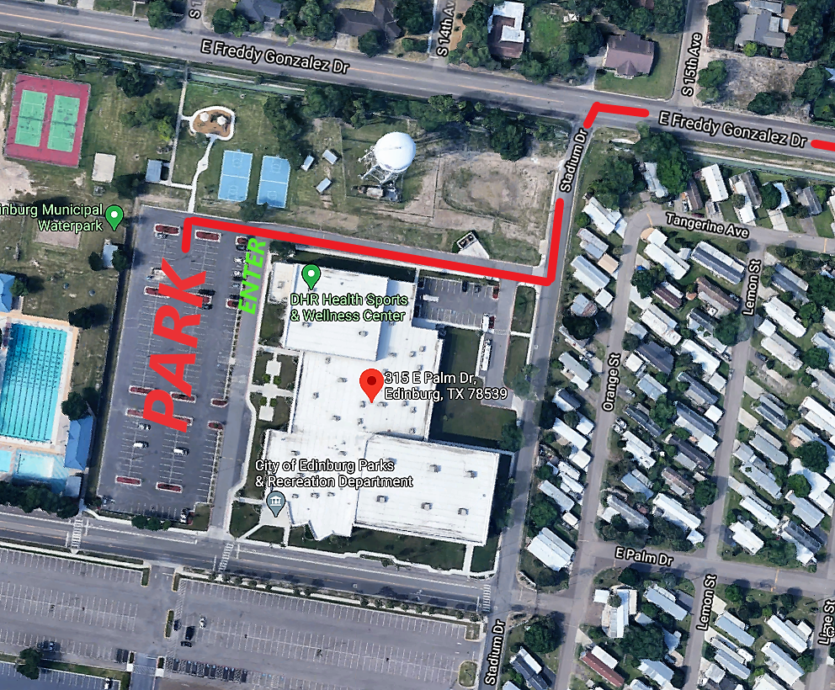

EARLY WEIGH-INSTRUCTIONS:

park vehicle in designated area, send one coach into building to get packet. THSwpa staff will get said coaches cell number and send text when we are ready to weigh your competitors. Upon receiving text team will enter building where packet was retrieved and shown to weigh in area. While in building all covid guidelines will be followed, social distancing and face mask must be worn at all times.

pACKETS WILL BE ISSUED UPON RECEIVING:
- ENTRY FEE PAYMENT
- State and Regional release forMS
- drug testing affidavits
- eligibility forms
- covid-19 screening certificate
- NOT REQUIRED: SCHOLARSHIP APPLICATION (SENIORS ONLY, ONE PER SCHOOL)

Packets will include:
- LIFTERS REGIONAL CERTIFICATE
- Lifters card (MUST HAVE OPENERS TO GET WEIGHED)
- coaches wristbands
- 1 wristband more than number of lifters up to 3 wristbands max.
- 1 back spotter wristband
- WRAPPERS WRISTBANDS CAN BE PURCHASED AT $10.00 EACH (MAXIMUM 2)

oNCE TEAM IS FINISHED WITH WEIGH-INS WE ASK THAT YOU EXIT THE PARKING LOT. tHANK YOU IN ADVANCE FOR YOUR COOPERATION.

2021 REGION v DIVISION I REGIONAL CHAMPIONSHIPS

Weigh-In Date: March 6,2021

Weigh-In Time: 6a 5:30 – 7:00 AM
5a 12:00 – 1:30 PM

Location: BERT OGDEN ARENA (VIPERS TRAINING ROOM)

sESSION #1 **6a**
bERT oGDEN aRENA
5:30-7:00 WEIGH-INS 6A
6:00 OPEN DOORS FOR COMPETITORS/COACHES/JUDGES (IDENTIFIED BY WRISTBANDS)
6:45 JUDGES MEETING
7:00 OPEN DOORS FOR SPECTATORS
7:15 COACHES MEETING (LOCATION TBD)
8:00 BARS LOADED COMPETITION BEGINS 6A
11:00 COMPETITION COMPLETE
11:30 EMPTY ARENA (PREP FOR 5A COMPETITION
SESSION #2 **5A**
bERT oGDEN aRENA
12:00- 1:30 WEIGH-INS 5A
12:30 OPEN DOORS FOR COMPETITORS/COACHES 6A (IDENTIFIED BY WRISTBANDS)
1:15 JUDGES MEETING
1:30 OPEN DOORS FOR SPECTATORS
1:45 COACHES MEETING (LOCATION TBD)
2:30 BARS LOADED COMPETITION BEGINS 5A
7:30 COMPETITION COMPLETE
7:30 AWARDS CEREMONY
8:00 EMPTY ARENA
8:00 LOAD OUT OF ARENA

We will be presenting awards AT THE END OF THE SECOND SESSION. 6A AWARDS WILL BE EITHER MAILED, DELIVERED OR MAY MAKE ARRANGEMENTS TO PICK UP.

The following are some reminders that might be helpful.
- Bring the State and Regional release forms, drug testing affidavits, and eligibility forms to Weigh-in.
- Bring any scholarship applications.(must be seniors, 1 application per school)
- each school IS responsible for the entry fee for each lifter they have qualified.
- Lifters must be weighed nude or in underwear and/or bra(without underwire). Jewelry, glasses, metal, hair accessories, wet hair, and any clothing not previously stated are strictly forbidden. If a question exists regarding weight of undergarments, the lifter may be requested to reweigh in the nude.
- There will be no one allowed in the weigh-in area except Weigh-In Officials.
- At the Regional and State meets, lifters must compete in their declared and qualified weight class. Failure to make proper weight will eliminate the lifter from all competition.
- A lifter who qualifies for the Regional Meet may qualify for the State Meet by 1) either finishing first or second in her weight class, 2) by posting a qualifying total for her class as follows or 3) by qualifying within the “top 2 rule by classification”. (Ex. At Regionals, if the top 2 finishers in a weight class are 5A, the top 2 6A girls, regardless of place, would go to State to represent their 6A Region).

Regional Qualifying totals State Qualifying totals
97.5 - 515 97.5 - 550
105.5 - 585 105.5 - 625
114.5 - 635 114.5 - 675
123.5 - 675 123.5 - 725
132.5 - 720 132.5 - 775
148.5 – 775 148.5 - 800
165.5 - 785 165.5 - 825
181.5 – 810 181.5 - 850
198.5 – 830 198.5 - 875
220.5 – 865 220.5 – 900
259.5 - 890 259.5 - 925
SHW – 915 SHW – 950

