THSWPA

Region 4 Division 1 2025 Letter

Coaches,

My email address is: [jcasaa@alvinisd.net](mailto:colton.henderson@bellsisd.net) if you have not received an email from me in the past please send me a message so I can add you to my contact list.

Here is some other information that might be helpful:

* The Regional and State fee has been raised to $50 this year.
* See attachment for instructions on creating a Coaches’ Account on the website.
* We are creating a Hall of Honor, if you have any nominations for coaches please email me with a “resume”.
* Meet Results need to be emailed to me by 4:00 p.m. on the Monday following your meet. **Please send me word through email if you are hosting a meet, at least one member of the powerlifting coaching staff must be a certified judge through the girl’s test accessible on boys website.**

**Results:** We will only use the Power-Score system for the rankings again this year. This is a free download and is a very easy system to use at the meets. All meets must use this form and send it to me in this format. Results sent to me in any other format **WILL NOT** be included in the rankings.

**Dues:** Boys and Girls dues are sent to different places so please inform your business department accordingly. State dues are $100.00 and must be postmarked by January 24, 2025. If the school Membership Fee is received after January 24, 2025, a late fee of $200 will be added to the membership fee and will only be accepted until February 10, 2025. Any dues postmarked past that date will be returned and your lifters will be disqualified from the Regional meet. Please make sure your business department is also aware of this deadline.

Complete the registration form and send it along with payment to:

## THSWPA PO Box 3021

**Brownsville, Texas 78523 (this is not the address for the Girls & Boys, make sure to mail TWO checks for your dues.)**

**Last Meet:** The last qualifying date will be Saturday, February 15, 2025. All judges MUST be certified for a last qualifying meet. All results from the last qualifying date must be sent to me by MIDNIGHT, February 15, 2025. **Weight class declarations must be made by 4:00 p.m. on Monday, February 17, 2025.** If I do not hear from you and you have a lifter who is in the top 12 in two weight classes she will be placed in the heavier weight class. **Equipped/Unequipped declarations must also be made by 4:00 p.m. on Monday, February 17, 2025.**

# Regional Meets:

**6A Equipped:** will compete in the Alvin High School Comp. Gym, Saturday February 22th and early weigh in will be February 21st, 2025 at Alvin High School.

**5A Equipped:** will compete in the Alvin High School Comp. Gym, Tuesday February 25th and early weigh in will be Monday February 24, 2025 at Alvin High School Comp. Gym.

**Unequipped:** will compete at Bay City High Schoolon Thursday February 27, 2025, Early weigh ins will be Wednesday February 26th with time to be announced. With more lifters we will lift them together

The entry fee this year will be $50 per lifter and **checks will be made out to: Alvin** ISD Athletics. Tickets at the door are $5. We will send out more details as the meet gets closer.

**State Meet:** The state meet will be in Edinburg @ Burt Ogden Arena March 12-15, 2025. 6A will lift on Wednesday March 12th with early weigh -ins on Tuesday March 11th. 5A will lift on Saturday March 15th and early weigh-in on Friday March 14th. Unequipped will lift on Thursday evening. Times will be sent out soon.

**Rule Clarifications:**

The UPDATED Rule book is posted on the site. All Changes will be Highlighted in yellow.

# Qualifying for Regional and State Competition:

The top 12 lifters from each weight class will qualify for Regional competition. There are two ways to qualify for Regionals: be in the top 12 of your weight class for your UIL classification or, reach your weight class’s automatic total.

There are two ways to qualify for State: finish with one of the top two totals at Regional competition or, reach your weight class’ automatic total at the Regional meet.

Finally, Coaches, Please have your kids sign up for the scholarships. Again this year the THSWPA will give 5 - $1000 Scholarships per region. Very important that the scholarship packet is complete or it will not even be considered (all letters, application and transcript.)

Good Luck to you all and I hope to see you around at the meets.

If any rules questions or general concerns please call/text or email me. 432-202-5029 or [jcasas@alvinisd.net](mailto:colton.henderson@bellsisd.net)

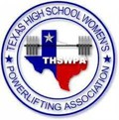Joe Casas

THSWPA Region 4, Director Division 1 Alvin HS

# Powerlifting Coaches

## How to request a Coach’s account to allow for creation of a team roster.

1. 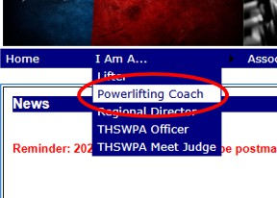On the THSWPA home page under the **I Am A** menu, click on **Powerlifting Coach**.
2. 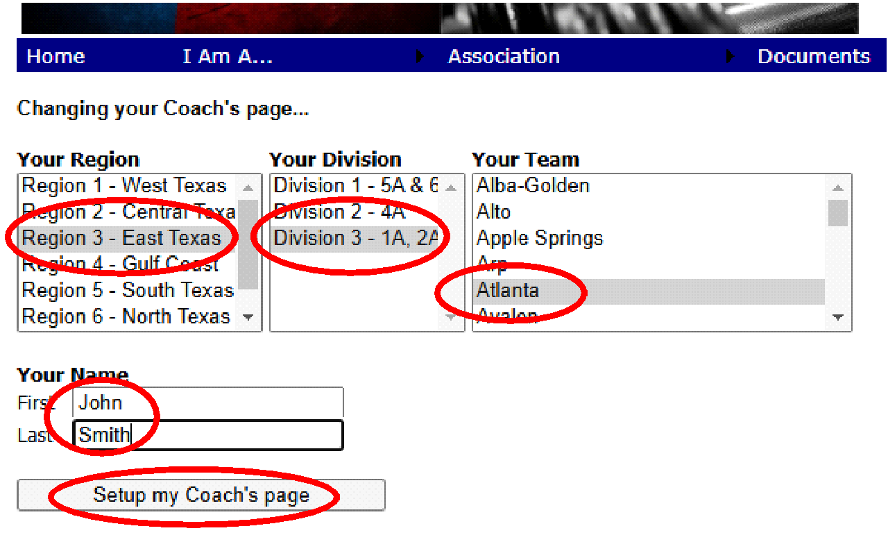Select your **Region**, **Division** and **Team** from the lists. Then enter your name. When you’re done click **Setup My Coach’s Page**.
3. Click **Team Account** to request your account.

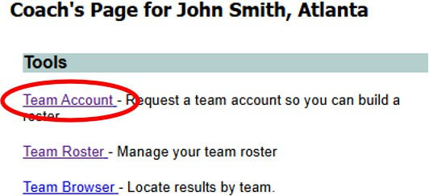

1. Fill in the entire form then click Request Account.

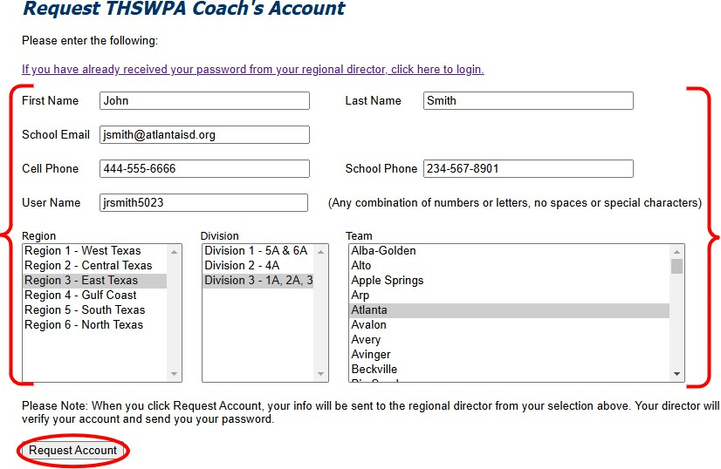

1. You will receive verification of your request.

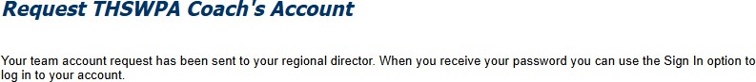

1. Your regional director will send you your password for the account. When you receive your password you can return to the THSWPA website and log in.



1. 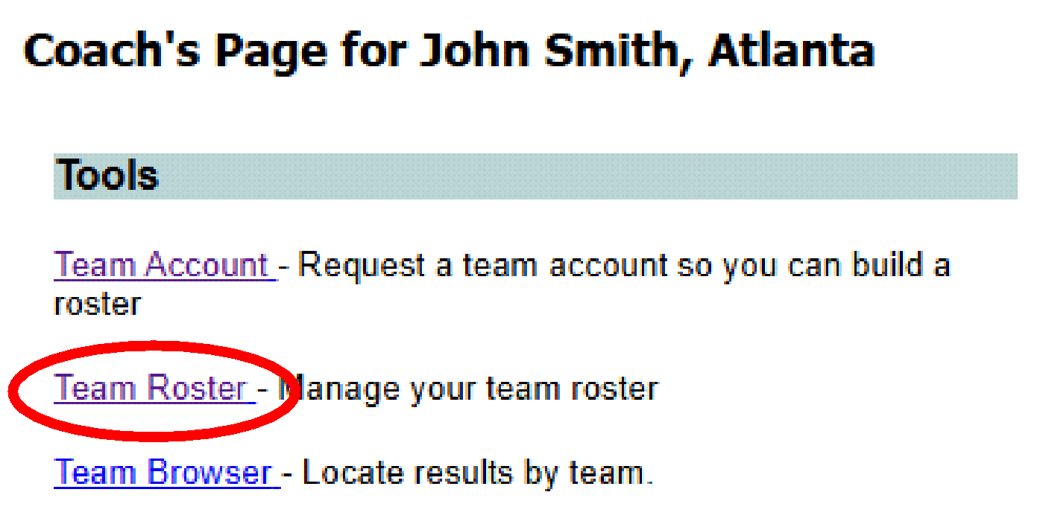After you’ve logged in, go back to your Coach’s Page, then click **Team Roster**.
2. To enter an athlete, first click **Add New Athlete**. Then click the **Edit** button next to the new athlete.

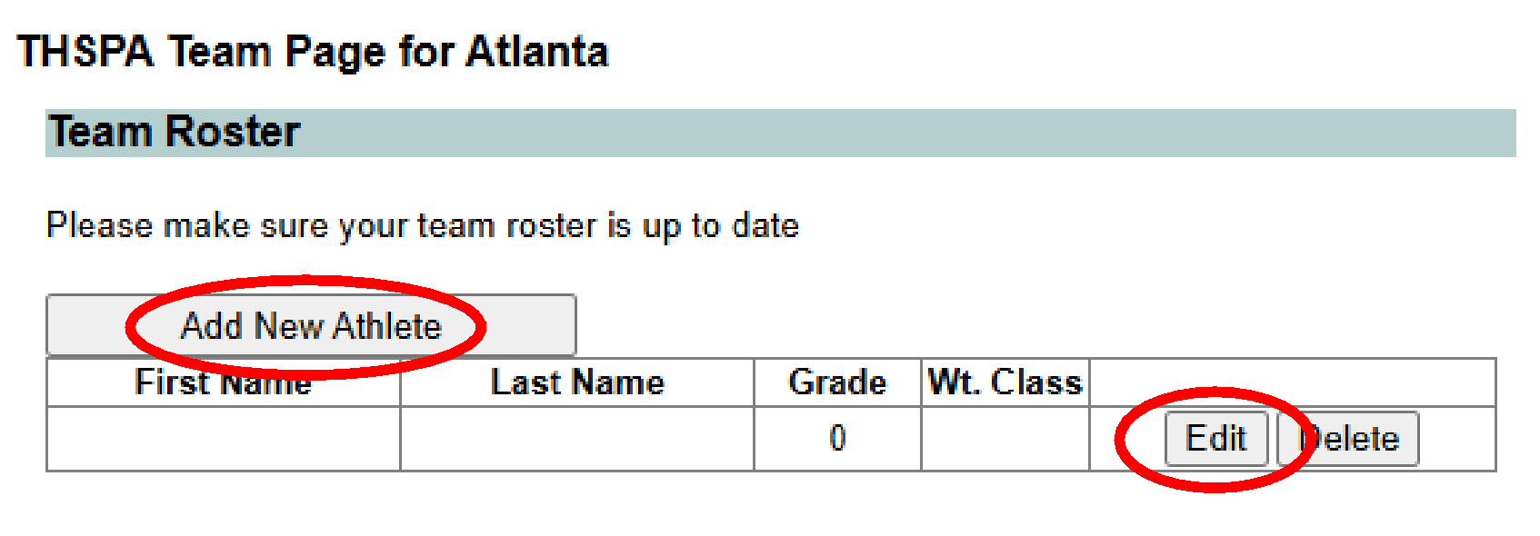

1. Edit the athlete’s info then click **Update** to save your changes.

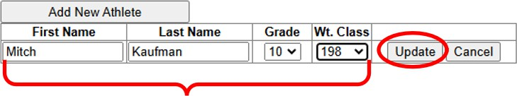

1. Continue until your roster is complete. You can return to this page at any time during the season to update your roster.