Powerlifting Coaches

How to request a Coach’s account to allow for creation of a team roster.

- On the THSWPA home page under the I Am A menu, click on Powerlifting Coach.
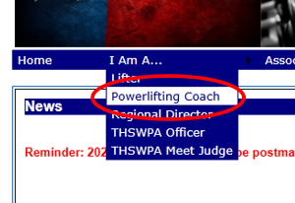

- Select your Region, Division and Team from the lists. Then enter your name. When you’re done click Setup My Coach’s Page.

- Click Team Account to request your account.
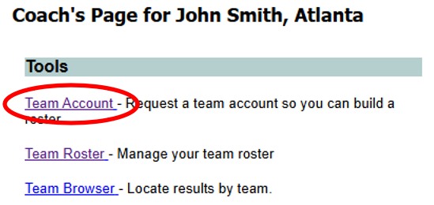

- Fill in the entire form then click Request Account.

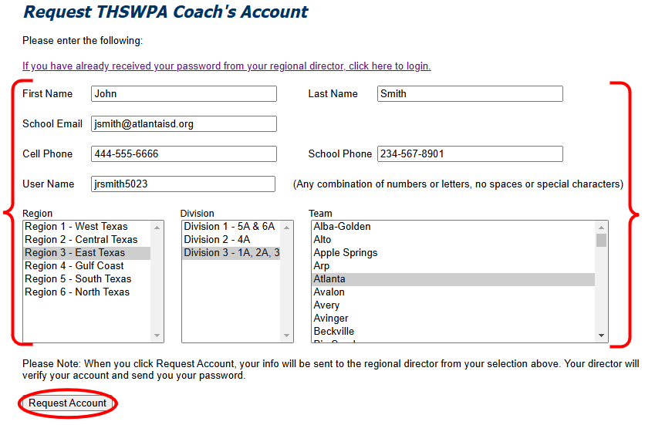

- You will receive verification of your request.

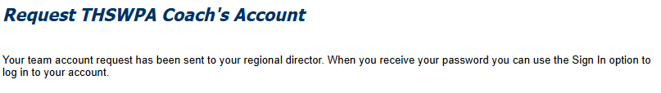

- Your regional director will send you your password for the account. When you receive your password you can return to the THSWPA website and log in.

- After you’ve logged in, go back to your Coach’s Page, then click Team Roster.
- To enter an athlete, first click Add New Athlete. Then click the Edit button next to the new athlete.
- Edit the athlete’s info then click Update to save your changes.
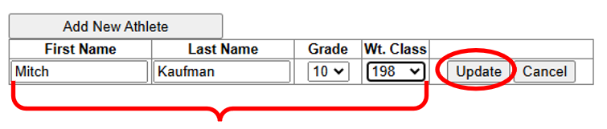

- Continue until your roster is complete. You can return to this page at any time during the season to update your roster.

