THSWPA
2019 STATE CHAMPIONSHIPS

EXTRACO EVENTS CENTER
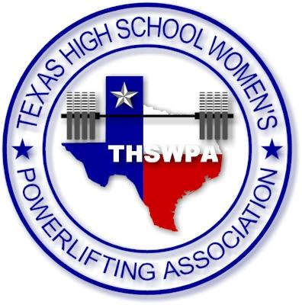
4601 BOSQUE BLVD.
WACO, TEXAS 76710

ENTRY FEE $35 PER LIFTER
CHECKS PAYABLE TO
THSWPA

packets will include
1 wrist band (coach) more than number of lifters up to 4 wristband max
state qualifying lifters will receive wristband upon being weighed in
you may purchase up to 4 wrapper wristbands per team @ $10.00 each at registration
parking for each day is $5

state meet itinerary
thursday night march 14th
weigh ins 5:00 – 7:00
1a/2a – 3A – 4a

friday morning march 15th
weigh ins 5:30 – 7:00
1a/2a – 3A – 4a
judges meet at 6:45
coaches meet at 7:15
competition starts at 8:00

friday night march 15th
weigh ins 5:00 – 7:00
5a – 6a

saturday morning march 16th
weigh ins 5:30 – 7:00
5a – 6a
judges meet at 6:45
coaches meet at 7:15
competition starts at 8:00

