THSWPA
2023 STATE CHAMPIONSHIPS

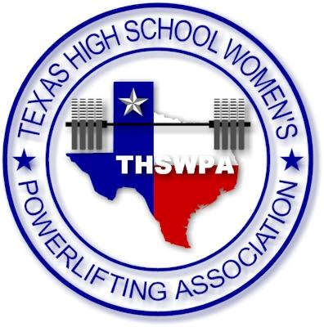
COMERICA CENTER
2601 AVENUE OF THE STARS
FRISCO, TX 75034

ENTRY FEE $35 PER LIFTER
CHECKS PAYABLE TO
THSWPA

packets will include
1 wrist band (coach) more than number of lifters up to 4 wristband max
state qualifying lifters will receive wristband upon being weighed in
you may purchase up to 2 wrapper wristbands per team @ $10.00 each at registration
parking for each day is $10

state meet itinerary

tuesday night march 14th
weigh ins
1A/2A – 3:00 – 5:00
6a – 4:00 – 6:00
wednesday march 15th  1a/2a – weigh ins am 5:30 – 7:00  judges meet at 6:45  coaches meet at 7:15  1a/2a – competition starts at 8:00  lunch break 12-1  holding / warm-up area open @ 11:00  6a – weigh ins 11:00 – 12:30  6A – competition starts at 1:30 pm  early weigh ins 3A  3A small – 3:00 – 5:00  3A big – 4:00 – 6:00 | thursday march 16th  3A small – weigh ins am 5:30 – 7:00  judges meet at 6:45  coaches meet at 7:15  3A small – competition starts at 8:00  lunch break 12-1  holding / warm-up area open @ 11:00  3A big – weigh ins 11:00 – 12:30  3A big – competition starts at 1:30 pm  early weigh ins 4A  4A small – 3:00 – 5:00  4A big – 4:00 – 6:00
friday march 17th  4A small – weigh ins am 5:30 – 7:00  judges meet at 6:45  coaches meet at 7:15  4A small – competition starts at 8:00  lunch break 12-1  holding / warm-up area open @ 11:00  4A big – weigh ins 11:00 – 12:30  4A big – competition starts at 1:30 pm  early weigh ins 5A  5A small – 3:00 – 5:00  5A big – 4:00 – 6:00 | saturday march 18th  5A small – weigh ins am 5:30 – 7:00  judges meet at 6:45  coaches meet at 7:15  5A small – competition starts at 8:00  lunch break 12-1  holding / warm-up area open @ 11:00  5A big – weigh ins 11:00 – 12:30  5A big – competition starts at 1:30 pm

