2021 THSWPA STATE CHAMPIONSHIPS

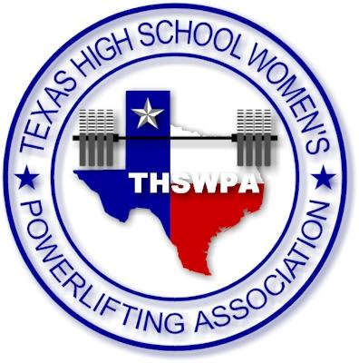
AMERICAN BANK CENTER ARENA
1901 N. SHORELINE BLVD.
CORPUS CHRISTI, TX 78401

ENTRY FEE $35 PER LIFTER
CHECKS PAYABLE TO
THSWPA

packets will include
1 wrist band (coach) more than number of lifters up to 4 wristband max
state qualifying lifters will receive wristband upon being weighed in
you may purchase up to 2 wrapper wristbands per team @ $10.00 each at registration
parking for each day is $5

state meet itinerary

wednesday night march 17th
early weigh ins 4:00 – 5:30
1a/2a – 3A
early weigh ins 6:00 – 7:30
6A
thursday morning session march 18th  1a/2a – 3a  weigh ins 5:30 – 7:00  judges meet at 6:45  coaches meet at 7:15  competition starts at 8:00  thursday afternoon session march 18th  6a  weigh ins 1:00 – 2:30  judges meet at 1:45  coaches meet at 2:45  competition starts at 3:30 pm  early weigh ins 4A  4a small school  weigh ins 4:00 – 5:30  4a big school  weigh ins 6:00 – 7:30 | friday morning session march 19th  4a small school  weigh ins 5:30 – 7:00  judges meet at 6:45  coaches meet at 7:15  competition starts at 8:00 am  friday afternoon session march 18th  4a big school  weigh ins 12:30 – 2:00  judges meet at 1:15  coaches meet at 2:15  competition starts at 3:00 pm  early weigh ins 5A  5a small school  weigh ins 4:00 – 5:30  5a big school  weigh ins 6:00 – 7:30
saturday morning session march 20th
5a small school
weigh ins 5:30 – 7:00
judges meet at 6:45
coaches meet at 7:15
competition starts at 8:00 am
saturday afternoon session march 20th
5a big school
weigh ins 12:30 – 2:00
judges meet at 1:15
coaches meet at 2:15
competition starts at 3:00 pm
State Meet Itinerary

Wednesday March 17th

1a/2a – 3a
4:00-5:30 early weigh in
5:30 clear weigh-in area
6a
6:00-7:30 early weigh in
7:30 clear weigh area

packets will be available outside the arena if weather permits. no entry into arena during weigh-ins. we will weigh-in by team, please keep athletes aware of social distancing and face covering both required at weigh ins and competition.

Thursday March 18th

AM SESSION
1a/2a – 3a
5:30 – 7:00 weigh ins
6:00 doors open for competitors/coaches/judges
6:45 judges meeting
7:00 doors open for spectators
7:15 coaches meeting
8:00 competition starts
12:30 award ceremony (judges and workers lunch)
1:00 clear arena

PM SESSION
6a
1:00-2:30 weigh ins
1:30 doors open for competitors
1:45 judges meeting
2:30 doors open for spectators
2:45 coaches meeting
3:30 competition starts
7:00 awards ceremony
7:30 clear arena

4A small school
4:00-5:30 early weigh ins
5:30 clear weigh in area
4A big school
6:00 – 7:30 early weigh ins
7:30 clear weigh in area
State Meet Itinerary

Friday March 19th

AM SESSION
4A small school
5:30 – 7:00 weigh ins
6:00 doors open for competitors/coaches/judges
6:45 judges meeting
7:00 doors open for spectators
7:15 coaches meeting
8:00 competition starts
12:00 award ceremony (judges and workers lunch)
12:30 clear arena

PM SESSION
4A big school
12:30 – 2:00 weigh ins
1:00 doors open for competitors
1:15 judges meeting
2:00 doors open for spectators
2:15 coaches meeting
3:00 competition starts
6:30 awards ceremony
7:00 clear arena
7:30 clear weigh in area

5A small school
4:00-5:30 early weigh ins
5:30 clear weigh in area
5A big school
6:00 – 7:30 early weigh ins

State Meet Itinerary

Saturday March 20th

AM SESSION
5A small school
5:30 – 7:00 weigh ins
6:00 doors open for competitors/coaches/judges
6:45 judges meeting
7:00 doors open for spectators
7:15 coaches meeting
8:00 competition starts
12:00 award ceremony (judges and workers lunch)
12:30 clear arena

PM SESSION
5A big school
12:30 – 2:00 weigh ins
1:00 doors open for competitors
1:15 judges meeting
2:00 doors open for spectators
2:15 coaches meeting
3:00 competition starts
6:30 awards ceremony
7:00 clear arena

